Wealth immersion introduction

- Welcome to the RPI Education Wealth Immersion Program.
This program is designed to immerse you into a whole new way of thinking in regards to wealth and wealth building.
The majority of us have been programmed a specific way throughout our lives in how we view money and wealth. This information has been passed down to us from our parents, our schools and our communities, shaping our beliefs and behaviors about money and wealth.
This has produced a working and middle class society for the majority of people, which would be fine if this class sector was not at risk for extinction. The information we have been taught about money, simply no longer works.
Society is in a crisis and we cannot continue this way.
Fortunately, there is another way.
While the majority of the population is struggling financially, a small percentage has been and always will be thriving.
This is what we refer to as the Top 2%.
It’s time to start thinking differently , acting differently and investing differently.
And this is what the RPI Wealth Immersion Program is all about.
We have created a step by step curriculum for you to follow to get the information you need to transform your wealth over the next 12 months.
We have organized this information into 7 key areas that we focus on at RPI Education.
  - Key #1 - Investing in Real Estate
  - Key #2 - Mastering Mortgages and Strategic Leverage
  - Key #3 - Self-Directing Passive Investments
  - Key#4 - Insurance to protect and grow wealth
  - Key #5 - Strategic Accounting practices and Tax Structures
  - Key #6 - Incorporating
  - Key #7 - Estate Planning for future generations
We believe that each of these areas are essential in wealth building and must be implemented into one’s wealth plan in order to maximize one’s wealth.
We have incorporated specific concepts and methodologies that the top 2% use to build wealth and show you how you can do the same.
Remember, we are here to guide you on your wealth journey, but you need to do the work and actively participate.
Each section consists of a series of videos/webinars for you to watch and take notes, downloads for you to complete and learning tools for you to use!
Taking Action is the key to success so make sure to review all the information in each section in order.
Do the activities and ask your question on our FB Members page (you will need to request access) as well as on LIVE group coaching every other week! Register on Eventbrite.
Get answers from RPI experts across the globe and grow your network with other RPI Members.
We are an interactive community that not only provides you with this essential information, but provides you with the support you need to take action!
View more
- TEXT & IMAGES
Edit

Let’s Get Started

Before you dive into each key area, we advise that you complete the following activities to get an accurate assessment of where you currently are on your wealth journey and where you want to go.
Download the files in the following sections and save them so you can print them off and refer to them on a regular basis.


Wealth Questionnaire
- TEXT & IMAGES
Edit

Wealth Questionnaire
If you haven't already done so, complete your Wealth Questionnaire and book a Discovery Call. Our Wealth Coach will talk to you about different options to accelerate your wealth building.



Set Your Goals
It is impossible to reach your destination if you don't know where you're going. Goals help you create a road map to achieve them. Use this form to generate your goals.

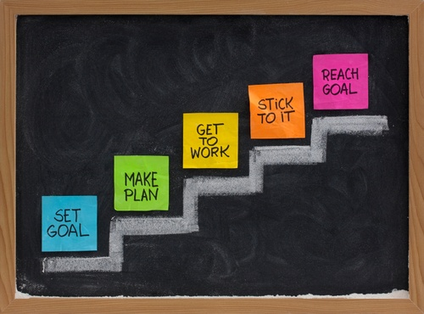

Gratitude Pad
- TEXT & IMAGES
Edit

Gratitude
Pausing to reflect and truly feel appreciative for the millions of things going well in your daily life is one of the most valuable practices you can do. Practicing gratitude not only helps you feel more grounded and peaceful.

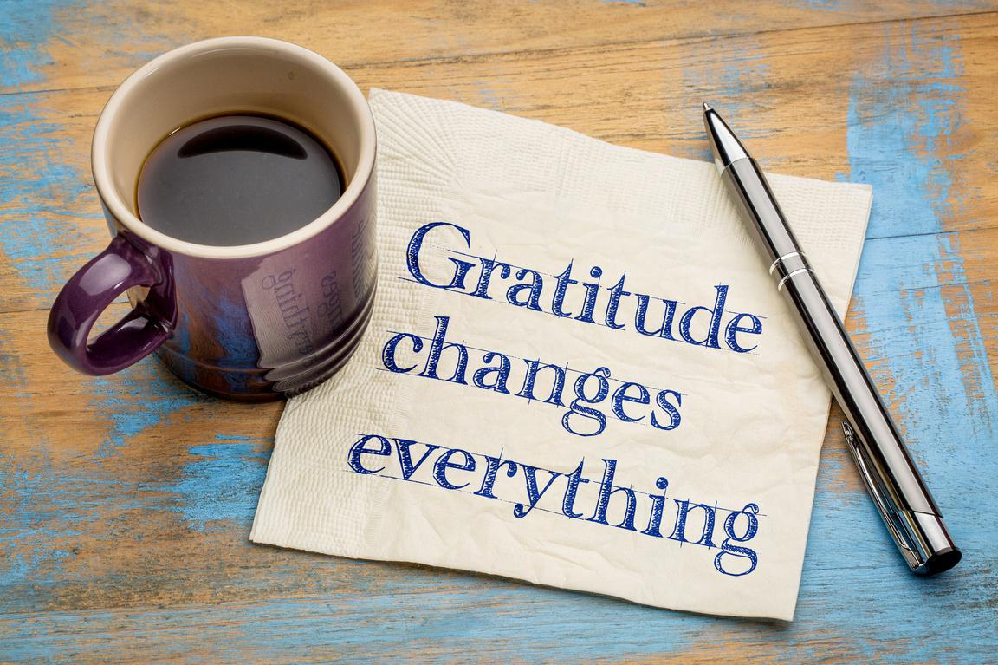

Read our Book
- TEXT & IMAGES
Edit

Read Our Book
Our book will guide you through our journey and the mistakes we made along the way. Use this to avoid making those same mistakes and save yourself money in the process.



Start thinking like the top 2%
- TEXT & IMAGES
Edit
Not only will we show you what the top 2% do, we also will show you how the top 2% feel.
Watch these webinars to develop a mindset like the Top 2%

Priming Activities
- TEXT & IMAGES
Edit

Priming
When you learn how to leverage the very real psychology of priming, you'll experience an incredible shift in the quality of your thoughts and emotions. When you prime your mind to experience more positivity, you'll not only find more fulfillment in the everyday, but you'll also become better at reaching your goals. - Tony Robbins

CREATE YOUR PERSONAL PRIMING RITUAL
We recommend that you create a personal ritual that you go through every morning to set a positive mindset and maintain peak state throughout the day.
Although this needs to be authentic to you, we are including some examples of priming for you to get some ideas and make your own!

EXAMPLE PRIMING ROUTINE:
WAKE UP EARLY
Try to program your body to wake up between 4-5 AM. Although you may need to set an alarm at first, try to learn to wake up naturally to make sure your body is fully rested.
Drink 1 cup of water with lemon
A natural antioxidant to kickstart your kidneys and clean your gut.
Full body stretch
2-5 minutes. Wake your body up starting with head/neck rolls and work your way down to your toes. This gets your blood circulating and ready for the day.
Mindset priming
Follow this Tony Robbins priming routine and make it your own. Do this EVERY day. NO EXCEPTIONS
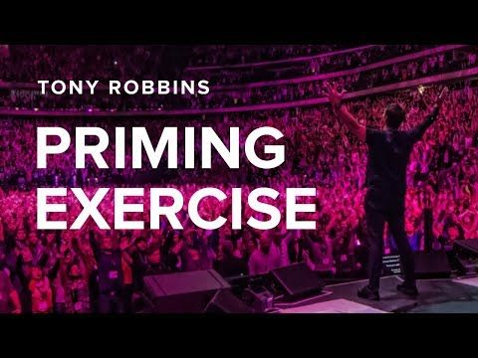
View more
- TEXT & IMAGES
Edit

READ
Now that your body is woken up and your mind is in a receptive state, it is time to read so you can strengthen your mindset.
Remember that this type of reading is quality over quantity, so pay attention to the information received, underline important passages and stop when you feel finished (you will know because you will feel so inspired you are ready to start your day!)
This means you may labour over 1 page or even a paragraph! This is NOT time for speed reading for information (that’s later) This is for mindset.
Some recommended readings:
  - The Prosperity Bible
  - THINK AND GROW RICH
  - LAWS OF SUCCESS
  - STRONGER THAN CIRCUMSTANCES
﻿

View less
- TEXT & IMAGES
Edit

1 HOUR OF GROWTH WORK
Now that you are primed and in peak state and in an uninterrupted environment, it is time for you to work on a focused activity to bring you closer to your goals and make sure to review your goals every day before you get started!
Set a timer for 59 minutes and GO!
Use this time to unleash your ideas and take massive action.
Stay open and use your inner instincts and trust them.
This hour can range from brainstorming a list of ideas, to analyzing a spreadsheet , to writing a chapter in a book…. anything that gets you closer to your goal as long as it is MUST DO work and not BUSY WORK.
Tip - use this hour every day to work your way through the RPI Wealth Immersion Program!!!
We do this work at this time because as soon as the rest of the world wakes up, we are no longer in growth mode, but instead reactive mode, so make sure to schedule this hour every day!

View more
- TEXT & IMAGES
Edit

FUEL YOUR BODY FOR PEAK ENERGY AND STAY FIT
You need to learn to eat for success as well as schedule fitness into your weekly regime. Plan your meals and track them every day! Write everything down and weigh yourself every morning.
Another tip is the quality of food you put in your body!
Forget fancy, expensive organic food……support local farmers and get farm fresh food delivered to your doorstep!
If you are in Ontario, Canada click here.
If you are in US or Canada enter your postal/ZIP code to find a farm near you.
Health is the first step to wealth and breakfast IS the most important meal of the day!
Watch this webinar from our personal health and nutrition coach, Ray McKenna
Ray actively posts in the RPI Education FB Members page so make sure to tune into live tips every day and try to stick to a healthy diet that will energize your body all day long.

View more
- TEXT & IMAGES
Edit

TAKE YOUR VITAMINS
Make sure to take your vitamins every morning to make sure you compensate for any deficits

Why do we need vitamins and minerals?
Your body can’t produce them.
  - Vitamins and minerals are called “essential” because they are needed to sustain life and health, and almost all must be obtained from your diet. The most common source is fruit and vegetables, but only 14% of U.S. adults and 9.5% of U.S. teens are eating the recommended servings.
Timing is everything.
  - The human body is not capable of storing most vitamins and minerals, so optimal health relies on nourishing the body with ideal amounts throughout the day.
Skipping today can hurt tomorrow.
  - Your body prioritizes health needs like doctors prioritize ER patients. As a result, you may not feel an immediate difference if you go a few days without essential vitamins or minerals, but you are jeopardizing long-term health benefits.

View more
- TEXT & IMAGES
Edit

COLD SHOWER THERAPY
Cold showers are an important part of the Wim Hof Method.
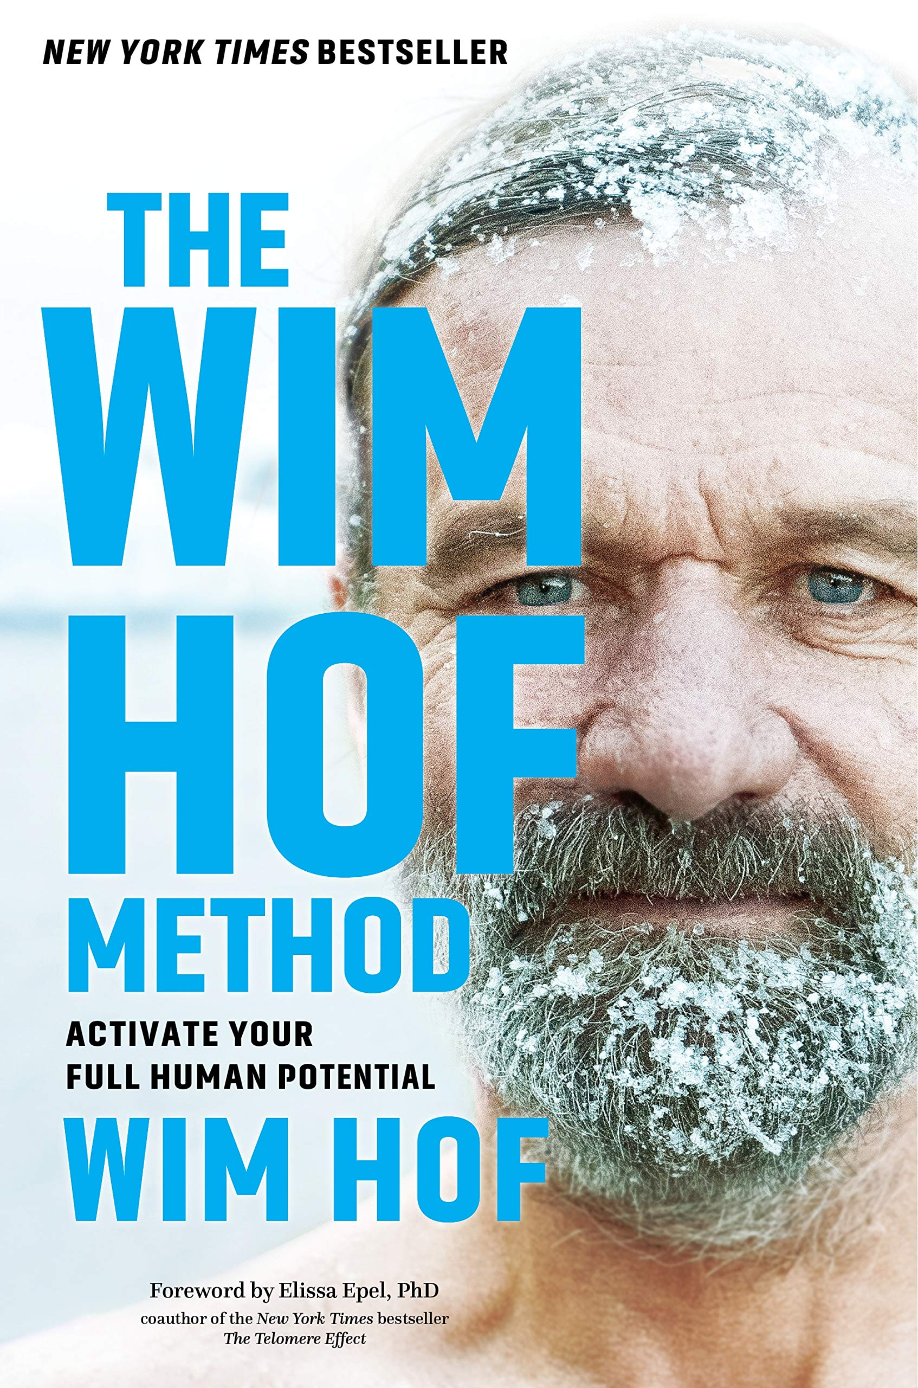
Although it may seem counterintuitive, these showers are actually beneficial for both your mind and your body. For the best benefits, incorporate cold showers into your daily routine. As this takes strength and dedication, Wim advises to gradually build up the duration and intensity. If you have no prior experience with cold showers, start with a regular shower and finish the last 30 seconds cold. You quickly notice that you are able to tolerate the cold more and more, and eventually cold showers and even ice baths become things you look forward to.

KNOWN BENEFITS OF COLD SHOWERS
Thousands of people from all over the world already incorporate cold showers into their daily routines. The main benefits reported by people who take cold showers regularly are listed below:
Reduced stress levels
Regularly taking cold showers imposes a small amount of stress on your body, which leads to a process called hardening. This means that your nervous system gradually gets used to handling moderate levels of stress. The hardening process helps you to keep a cool head, the next time you find yourself in a stressful situation.
Higher level of alertness
Cold showers wake your body up, inducing a higher state of alertness. The cold also stimulates you to take deeper breaths, decreasing the level of CO2 throughout the body, helping you concentrate. Cold showers thus keep you ready and focused throughout the day.
More robust immune response
Scientific studies have found that taking a cold shower increases the amount of white blood cells in your body. These blood cells protect your body against diseases. Researchers believe that this process is related to an increased metabolic rate, which stimulates the immune response.
Increased willpower
It takes a strong mind to endure the cold for extended periods of time. By incorporating cold showers into your daily routine, you are strengthening your willpower , which benefits many aspects of (your) daily life.
Weight loss
Research has shown that cold showers (and exposure to cold in general), in addition to increasing metabolic rate directly, stimulate the generation of brown fat. Brown fat is a specific type of fat tissue that in turn generates energy by burning calories. Cold showers, then, are an effective tool for people who are looking to lose a few pounds.
Watch this video on Wim Hof.
View more
- TEXT & IMAGES
Edit

DRESS FOR SUCCESS
Life is a fashion show and the world is your runway - Coco Chanel
Now that you are in peak state and have a Top 2% mindset, its time to look the part!
Choose clothes that make you feel comfortable and ready to seize the day!
This does not mean you need anything expensive or designer or even formal attire (although it is ok if that’s what makes you fit the part!)
As long as it is clean, neat, fits properly and makes you feel confident, go for it!!!

View more
- TEXT & IMAGES
Edit

Plan your week in advance and leave very little to surprise.
This should include your workouts and physical recreation times, time with family and friends, your down time to rest and recoup , time to review finances and even what and when you will eat!
Schedule it in your planner for a particular time , treat it like an appointment and make it happen!
Make sure to book off time in your schedule for our bi-weekly Group Coaching and Deals webinar online, 12 PM EST and get your questions answered LIVE!
Don’t forget to schedule time for learning the wealth immersion program everyday and make sure to work your way through the entire program as it will change your life! But to achieve the full results, you have to see it to completion, so let's get started!

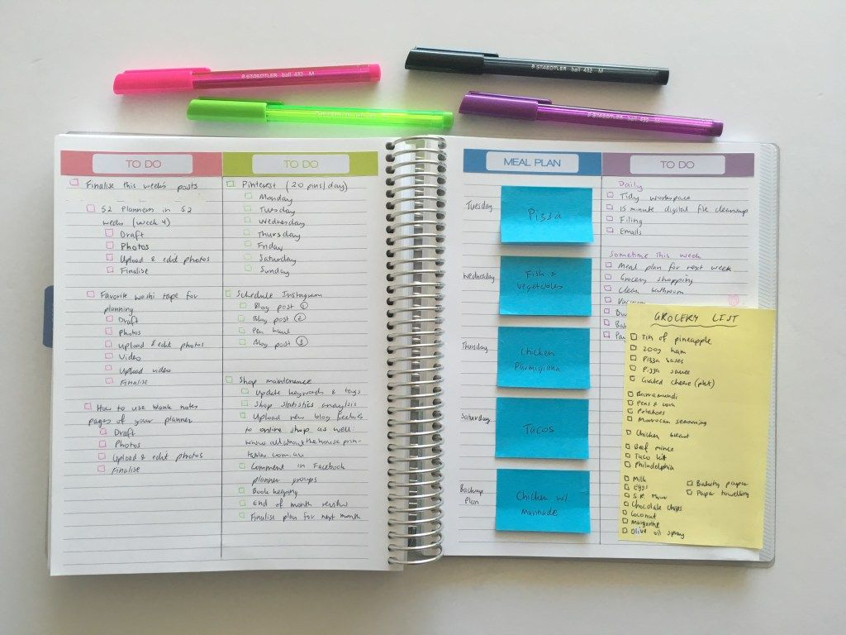
View more
- TEXT & IMAGES
Edit
Use the following to help you set up your priming activities for the morning.
- PDF VIEWER
Priming Check List.pdf
Download link visible
- QUIZ
Edit
  - What is the purpose of the RPI Education Wealth Immersion Program?
Correct answers: To teach people how to view money and wealth in a new way, To provide strategies for building wealth, To guide people on their wealth journey
  - How many key areas are covered in the RPI Wealth Immersion Program?
Correct answer: 7
  - What is Key #1 in the RPI Wealth Immersion Program?
Correct answer: Investing in Real Estate
  - What is the recommended time to wake up for priming according to the RPI method?
Correct answer: 4-5 AM
  - What is the main benefit of taking cold showers according to the RPI method?
Correct answer: Reduced stress levels
  - What is the importance of reading in the morning according to the RPI method?
Correct answer: To strengthen mindset and set a positive tone for the day
  - What is the purpose of completing the Wealth Questionnaire in the RPI method?
Correct answer: To assess one's current financial situation
  - What is the recommended step after completing the Wealth Questionnaire in the RPI method?
Correct answer: Set goals
  - What is the purpose of the personal priming ritual in the RPI method?
Correct answer: To set a positive mindset
  - What is the importance of dressing for success in the RPI method?
Correct answer: To boost self-confidence and mindset

